- (___/17) Chapter 18 and 19 Vocab
- ( ____/10) For each term explain a situation that demonstrates the ‘real world’ application of each of the following. Make sure your example clearly demonstrates your understanding of each concept.
  - Trade Deficit and Trade Surplus ( ____/2)
  - Current Account and Financial Account – you also need to define each term ( ____/6)
  - Appreciation and Depreciation ( ____/2)

- (___/25) The Balance of Payments (BOP) measures all international transactions between two countries. The chart below transactions between the US and China

United States | China
- Purchased $800 of goods and services  - Sent $100 of humanitarian aid  - Americans spent $200 in Chinese stock market  - American tourists spend $1000 in China | - Chinese tourists spend $1000 in the US  - Purchased $300 of goods and services  - Chinese purchased a $600 business in the US  - Chinese government purchased US. bonds

- Which country has a trade deficit and which has a trade surplus? Explain how you got your answer and calculate the value of each ( ____/5)
- Assuming these are all the transactions between these two countries, calculate the value of the current accounts for each country. Explain why one will have a current account deficit and the other will have a current account surplus. ( ____/5)
- Calculate the dollar value of US bonds held by the Chinese government. Explain how you determined your answer. Identify the relationship between financial inflows and outflows for each country ( ____/5)
- Assume that China experience significant inflation compared to the US. In general, explain what would likely happen to the current accounts for each country and the value of each country’s currency? ( ____/5)
- Assume instead that the interest rate increase in China compared to the US. In general, explain what would likely happen to financial accounts for each country and the value of each country’s currency? ( ____/5)

- (_____/26 Points) Practice FRQs
FRQ #1 (_____/6) 5.1
FRQ #2 (_____/6) 5.2
FRQ #3 (_____/8)
FRQ #4 (_____/6)

3.
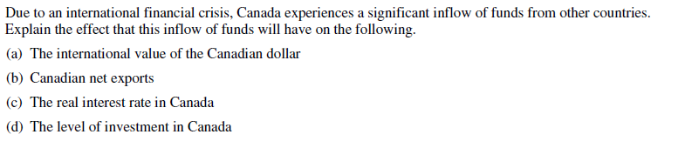
4.
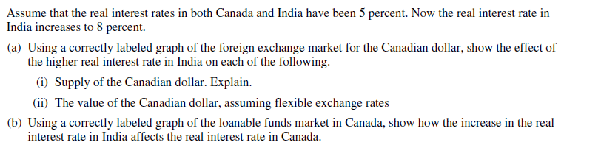
- (___/11) Multiple Choice Questions
- All of the following are true regarding international trade except
  - Countries experience a trade deficit when imports are greater than exports
  - Net exports will increase when that country's currency depreciates
  - Exports are considered a debit in a country's balance of trade
  - The balance of payment is a summary of a country's transactions with other countries
  - The primary components of the balance of payments are the current account and the capital (financial) account

- Which of the following would definitely move a country toward a current account deficit?
  - An increase in exports
  - An increase in imports
  - An larger capital account deficit
  - An increase in capital outflow
  - A decrease in foreign aid provided to other countries

- Which of the following is the best example of foreign direct investment?
  - The Chinese government buying United States Treasury bonds
  - A business in the United States selling machinery to a company in Japan
  - A United States citizen buying Mexican pesos.
  - The United States sending earthquake relief aid to Haiti
  - A Japanese software company buying a factory in the United States

- The value of a country's currency relative to another country's currency is called
  - capital flow
  - purchasing-power parody
  - the inflation rate
  - the exchange rate
  - appreciation

- If there is a large increase in the number of Europeans traveling to the United States while US citizens’ travel to Europe remains unchanged, which of the following is true
  - The euro will depreciate because the demand for euros will decrease
  - The euro will depreciate because the supply of euros will increase
  - The euro will appreciate because the demand for euros will increase
  - The dollar will appreciate because the demand of dollars will decrease
  - The dollar will appreciate because the supply of dollars will increase
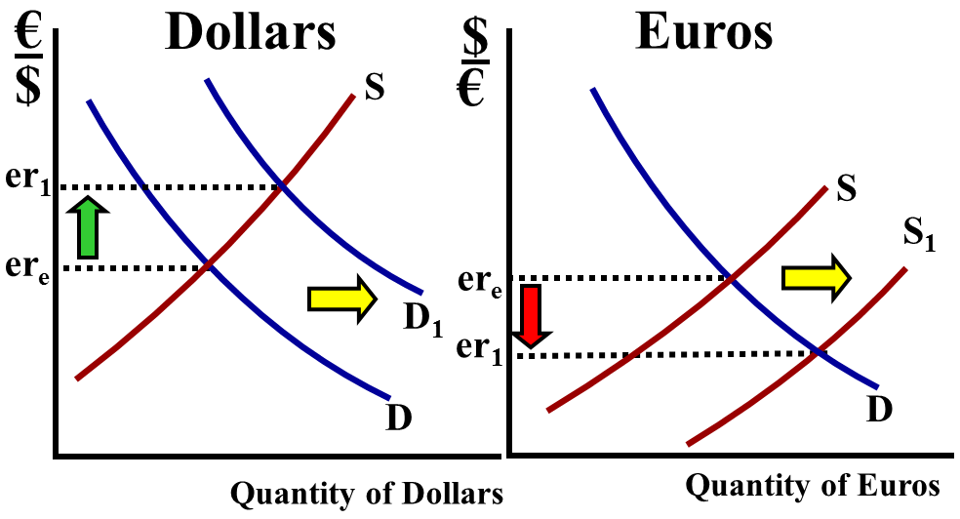
- Assume the inflation rate in Mexico is significantly higher than its trading partners. Which of the following will occur to the demand, supply, and international value of the Mexican Peso?
Demand Supply Value
  - Increase Increase Depreciate
  - Increase Decrease Appreciate
  - Decrease Increase Appreciate
  - Decrease Increase Depreciate
  - Decrease Decrease Depreciate
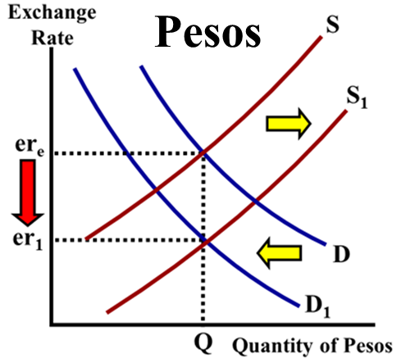
- Assume the real interest rate in country X increases relative to other countries. What will happen to the value of the currency and net exports in country X?
Value of Currency Net exports
  - Appreciate Decrease
  - Depreciate Increase
  - Stay the Same Stay the Same
  - Appreciate Increase
  - Depreciate Decrease
- Which of the following is an example of direct foreign investment?
a. An increase in the demand for US dollars by foreigners
b. A decrease in the supply of US dollars by Americans
c. The purchase of American planed by a Mexican company
d. The sale of financial service to a foreign investor by a US bank
e. A Chinese company buying a microprocessor factory in Korea

9. All of the following are counted in a nation's current account except
a. A $50,000 car imported from Italy
b. $500 of cheese exported from France
c. A $50 million Chinese factory purchased by a Canadian
d. $1 million donated in first aid supplies to Indonesia
e. $1,000 sent to Russia from a Russian working in the US

10. Which of the following would decrease the U.S. financial account?
a. A boat purchased by a British investment banker in Florida
b. A ski chateau purchased in Switzerland by an American entrepreneur
c. An American earns $1000 in the Japanese stock market
d. The purchase of $1000 of US Treasury bonds by a Chinese investor
e. The purchase of a foreign car by an American diplomat living in Costa Rica

11. An increase in Korea’s demand for U.S. goods would cause the US dollar to
a. Depreciate because of inflation
b. Depreciate because the U.S. would be selling more dollars to Korea
c. Depreciate because the U.S. money supply would increase as exports rise
d. Appreciate because Korea would be buying more U.S. dollars
e. Appreciate because Korea would be selling more U.S. dollars

